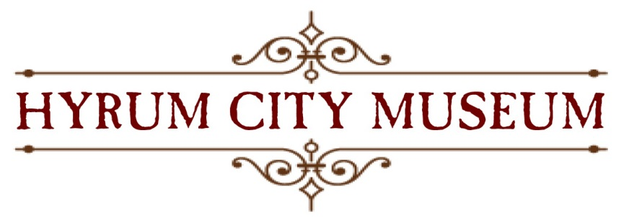

2nd Annual
Elite Hall Art and Quilt Show
Featuring the American West Historic Quilt Collection
November 4 & 5, 2016

PROSPECTUS AND ENTRY FORM

KEY DATES:
Entry Forms Due Saturday, October 22nd by 3:00 pm
Deliver Art Work Wednesday, November 2nd, 10:00--3:00 pm
(to museum) Thursday, November 3rd, 12:00--6:00 pm
Judging Friday, November 4th, afternoon
Art and Quilt Show Friday, November 4th, 5:00--8:00 pm
Saturday, November 5th, 10:00 am--3:00 pm
Pick Up Saturday, November 5th, 3:00--4:00 pm at Elite Hall
Tuesday, November 8th, 12:00--6:00 pm at the museum

ELIGIBILITY:
Everyone is eligible and encouraged to submit their best works. All artwork must be original. While awards will be given by category, judges will weigh pieces differently whether you are a student, amateur, or professional artist. Our goal is to offer a venue for local artists of all skill levels to become better acquainted with our community of artists, gain public exposure, hopefully sell some of their work, and even win an award. Please share this opportunity with your fellow artists, we want this show to grow and need your support!

THEME:
“Remember When…”
This event is open to artworks depicting any appropriate family-friendly subject. However, works created specifically for this year’s theme will be eligible to win our Poster Award and a $50 cash prize.

AWARDS:
Judges will award the following cash prizes: Best of Show ($100) and First Place ($50) in each category. Second and Third Place certificates will also be awarded in each category. Judges will not have access to artists’ name, only skill level. A Poster Award will be selected by the Elite Hall Art and Quilt Show Committee. An image of the Poster Award winner will be used for advertising and promotional purposes, with artist attribution. The Poster Award winner will receive a ($50) cash prize.
CATEGORIES:
Entries will be judged in the following categories:
1. Drawing (pencil, colored pencil, pastel) 5. Pottery, Ceramics
2. Painting (oil, acrylic, watercolor) 6. Wood, Sculpture
3. Photography, Graphic Arts 7. Glass, Mixed Media
4. Fiber (all)
2-D pieces must be framed, wired, and ready to hang; no saw-tooth hangers. Paintings/
photographs, including frame or outside dimensions of wall hangings cannot exceed 48”x48”. 3-D work cannot exceed six feet in any direction or 100 lbs.

SALES:
All entries may be available for purchase during the event and bear a sale price determined by the artist. However, the Elite Hall Art and Quilt Show staff will not directly sale any items. Rather, we will provide the artist’s contact information to any interested purchasers.

LIABILITY:
Although reasonable care will be taken in handling and displaying artwork, the Elite Hall Art and Quilt Show, its staff, and volunteers will not be responsible for damage or loss. Artists must pick up their work(s) at the designated time and location. Artist may arrange for artwork pickup by another party with proper notification.

ENTRY PROCEDURE:
□ Complete entry form.
□ A maximum of three pieces may be submitted.
□ Submit one digital image for each piece of work (JPEG) on a CD or email to museum@hyrumcity.com. The digital image should be labeled with its entry number, title, and the artist’s last name, separated by periods. For example, the first piece, a painting entitled “Old Main Street” by John Smith would be labeled: 1.OldMainStreet.Smith.jpg.
□ Drop-off entry form at the museum. (If closed, take it to the library.)
IMPORTANT: No changes to size or sales price of artwork will be permitted. Be sure frame size and sales price are correct on your Entry Form. Keep a copy of your entry form for reference.

THE SHOW:
This is meant to be an inclusive, engaging community event and all artists are encouraged to come interact with the public during show hours. Additionally, please invite your family, friends, and neighbors to attend. The renowned American West Historical Quilt Collection will also be on display. We appreciate your support and hope that you will help spread the word to other artists and art enthusiasts you know!

QUESTIONS:
Contact Hyrum City Museum Director Jami Van Huss at museum@hyrumcity.com or call
245-0208 (for a quick response, email is best).

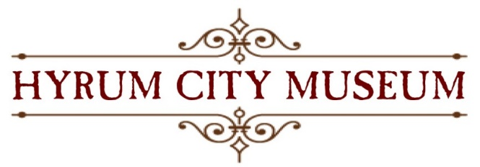

2nd Annual Elite Hall Art and Quilt Show
ENTRY FORM

Please complete this form and drop off with the CD of images (unless emailing) to the Hyrum City Museum* 50 West Main Street in Hyrum. You may take to the library** if the museum is closed. Entry forms and images must be received by Saturday, October 22nd at 3:00 pm. Please print clearly. If you do not want to sale any of your pieces, write “not for sale” below.

Your Name:______________________________ Circle One: Professional Amateur Student

Address:_________________________________ Telephone: ( )_____- ______ Text: Y / N

City, ST, Zip:_____________________________ Email: ______________________________

- Title:___________________________________________________________________

Category and Medium:_____________________________________________________

Installed Dimensions: (hxwxd) _________________ Sale Price: $__________________

- Title:___________________________________________________________________

Category and Medium:_____________________________________________________

Installed Dimensions: (hxwxd) _________________ Sale Price: $__________________

- Title:___________________________________________________________________

Category and Medium:_____________________________________________________

Installed Dimensions: (hxwxd) _________________ Sale Price: $__________________

I plan to drop my artwork off at the Hyrum Museum on Nov 2 / Nov 3 around ____________ am / pm.
I have read and agree to all conditions in this prospectus and entry form.

Signature:________________________________________________ Date:_____________________

*Hyrum Museum Hours: Tuesday & Thursday 12:00--6:00 pm and Wednesday & Saturday 10:00am--3:00 pm
**Hyrum Library Hours: Monday--Friday, 10:00 am--7:00 pm and Saturday 10:00 am--3:00 pm

