Volunteer Application and Waiver, Release, and Hold Harmless Agreement | 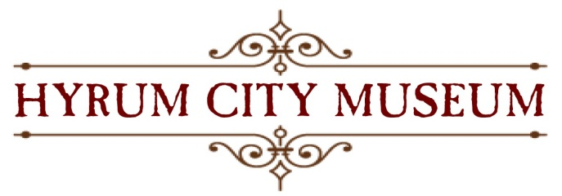

Contact Information
Name
Street Address
City
Preferred Phone
Other Phone
E-Mail Address

Availability

During which hours are you available for volunteer assignments?
Tuesday afternoons | Saturdays
Wednesday afternoons | Special Events
Thursday afternoons | Special Tours

Interests

Tell us in which areas you are interested in volunteering
Back in Time children’s activities
Docent
Exhibit Development/Enhancement
Fundraising
Group Tours (schools, scouts, church, civic, etc.)
Special Events
Other (please specify) ____________________________________________________________

Special Skills or Qualifications

Summarize special skills and qualifications you have acquired from employment, previous volunteer work, or through other activities, including hobbies or sports.

Previous Volunteer Experience

Summarize your previous volunteer experience.

Person to Notify in Case of Emergency
Name
Street Address
City
Preferred Phone
Other Phone
E-Mail Address

Agreement and Signature

By submitting this application, I affirm that the facts set forth in it are true and complete. I understand that if I am accepted as a volunteer, any false statements, omissions, or other misrepresentations made by me on this application may result in my immediate dismissal. Furthermore, I having read and understood the contents and nature of this agreement, state that I understand and agree that:
- I will perform the volunteer services pursuant to the above information.
- The above described activities many expose me, other museum staff, and volunteers to a variety of hazards. Dependent on the nature of the performance, the risk and injury attendant with the performance, whether foreseen or unforeseen, cannot be eliminated due to the nature of the performance.
- I agree to assume full responsibility for my own safety, and the safety of other members of my group.

By signing this release form, I agree to waive and discharge any and all claims to hold harmless the Hyrum City Museum and Hyrum City, their Boards, officers, employees, volunteers, and agents from any claims for injury or damages, except for our sole negligence, that may arise from, or in connection with my volunteer service. I understand this Agreement and I have read this Agreement in its entirety and I freely and voluntarily assume all risks and responsibilities associated therewith, and notwithstanding such, I agree to perform pursuant to this agreement and be bound by its conditions. This Agreement is intended to be as broad and inclusive as permitted by law. If any provision or any part of any provision of this Agreement is held to be invalid or legally unenforceable for any reason, the remainder of this Agreement shall not be affected thereby and shall remain valid and fully enforceable.

Name (printed)
Signature
Date

Our Policy

It is the policy of the Hyrum City Museum to provide equal opportunities without regard to race, color, religion, national origin, gender, sexual preference, age, or disability. Thank you for completing this application form and for your interest in volunteering with us.

